next →← prev

Exception Handling
The exception handling in java is one of the powerful mechanism to handle the runtime errors so that normal flow of the application can be maintained.
In this page, we will learn about java exception, its type and the difference between checked and unchecked exceptions.

What is exception
Dictionary Meaning: Exception is an abnormal condition.
In java, exception is an event that disrupts the normal flow of the program. It is an object which is thrown at runtime.

What is exception handling
Exception Handling is a mechanism to handle runtime errors such as ClassNotFound, IO, SQL, Remote etc.

Advantage of Exception Handling
The core advantage of exception handling is to maintain the normal flow of the application. Exception normally disrupts the normal flow of the application that is why we use exception handling. Let's take a scenario:
- statement 1;
- statement 2;
- statement 3;
- statement 4;
- statement 5;//exception occurs
- statement 6;
- statement 7;
- statement 8;
- statement 9;
- statement 10;
Suppose there is 10 statements in your program and there occurs an exception at statement 5, rest of the code will not be executed i.e. statement 6 to 10 will not run. If we perform exception handling, rest of the statement will be executed. That is why we use exception handling in java.
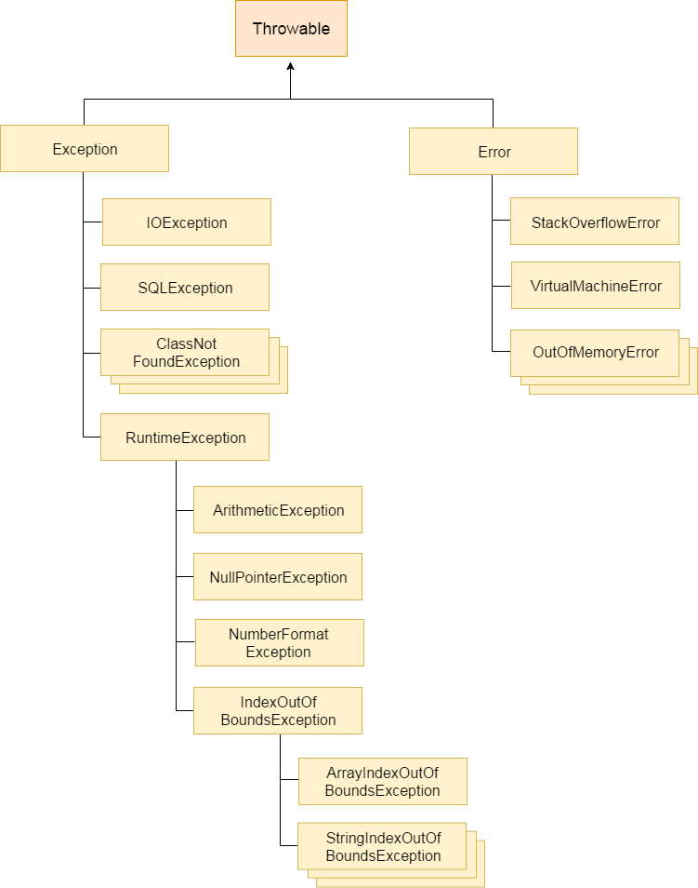

Types of Exception
There are mainly two types of exceptions: checked and unchecked where error is considered as unchecked exception. The sun microsystem says there are three types of exceptions:
- Checked Exception
- Unchecked Exception
- Error

Difference between checked and unchecked exceptions

1) Checked Exception
The classes that extend Throwable class except RuntimeException and Error are known as checked exceptions e.g.IOException, SQLException etc. Checked exceptions are checked at compile-time.

2) Unchecked Exception
The classes that extend RuntimeException are known as unchecked exceptions e.g. ArithmeticException, NullPointerException, ArrayIndexOutOfBoundsException etc. Unchecked exceptions are not checked at compile-time rather they are checked at runtime.

3) Error
Error is irrecoverable e.g. OutOfMemoryError, VirtualMachineError, AssertionError etc.

Common scenarios where exceptions may occur
There are given some scenarios where unchecked exceptions can occur. They are as follows:

1) Scenario where ArithmeticException occurs
If we divide any number by zero, there occurs an ArithmeticException.
- int a=50/0;//ArithmeticException

2) Scenario where NullPointerException occurs
If we have null value in any variable, performing any operation by the variable occurs an NullPointerException.
- String s=null;
- System.out.println(s.length());//NullPointerException

3) Scenario where NumberFormatException occurs
The wrong formatting of any value, may occur NumberFormatException. Suppose I have a string variable that have characters, converting this variable into digit will occur NumberFormatException.
- String s="abc";
- int i=Integer.parseInt(s);//NumberFormatException

4) Scenario where ArrayIndexOutOfBoundsException occurs
If you are inserting any value in the wrong index, it would result ArrayIndexOutOfBoundsException as shown below:
- int a[]=new int[5];
- a[10]=50; //ArrayIndexOutOfBoundsException

Java Exception Handling Keywords
There are 5 keywords used in java exception handling.
- try
- catch
- finally
- throw
- throws

Java try block
Java try block is used to enclose the code that might throw an exception. It must be used within the method.
Java try block must be followed by either catch or finally block.

Syntax of java try-catch
- try{
- //code that may throw exception
- }catch(Exception_class_Name ref){}

Syntax of try-finally block
- try{
- //code that may throw exception
- }finally{}

Java catch block
Java catch block is used to handle the Exception. It must be used after the try block only.
You can use multiple catch block with a single try.

Problem without exception handling
Let's try to understand the problem if we don't use try-catch block.
- public class Testtrycatch1{
- public static void main(String args[]){
- int data=50/0;//may throw exception
- System.out.println("rest of the code...");
- }
- }
Test it Now
Output:
Exception in thread main java.lang.ArithmeticException:/ by zero
As displayed in the above example, rest of the code is not executed (in such case, rest of the code... statement is not printed).
There can be 100 lines of code after exception. So all the code after exception will not be executed.

Solution by exception handling
Let's see the solution of above problem by java try-catch block.
- public class Testtrycatch2{
- public static void main(String args[]){
- try{
- int data=50/0;
- }catch(ArithmeticException e){System.out.println(e);}
- System.out.println("rest of the code...");
- }
- }
Test it Now
Output:
Exception in thread main java.lang.ArithmeticException:/ by zero
rest of the code...
Now, as displayed in the above example, rest of the code is executed i.e. rest of the code... statement is printed.

Internal working of java try-catch block
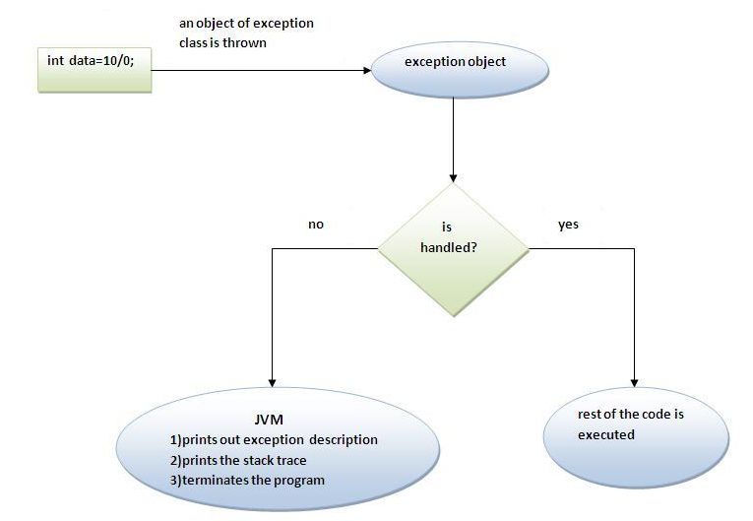
The JVM firstly checks whether the exception is handled or not. If exception is not handled, JVM provides a default exception handler that performs the following tasks:
- Prints out exception description.
- Prints the stack trace (Hierarchy of methods where the exception occurred).
- Causes the program to terminate.
But if exception is handled by the application programmer, normal flow of the application is maintained i.e. rest of the code is executed.

Java Multi catch block
If you have to perform different tasks at the occurrence of different Exceptions, use java multi catch block.
Let's see a simple example of java multi-catch block.
- public class TestMultipleCatchBlock{
- public static void main(String args[]){
- try{
- int a[]=new int[5];
- a[5]=30/0;
- }
- catch(ArithmeticException e){System.out.println("task1 is completed");}
- catch(ArrayIndexOutOfBoundsException e){System.out.println("task 2 completed");}
- catch(Exception e){System.out.println("common task completed");}

- System.out.println("rest of the code...");
- }
- }
Test it Now
Output:task1 completed
rest of the code...

Rule: At a time only one Exception is occured and at a time only one catch block is executed.

Rule: All catch blocks must be ordered from most specific to most general i.e. catch for ArithmeticException must come before catch for Exception .
- class TestMultipleCatchBlock1{
- public static void main(String args[]){
- try{
- int a[]=new int[5];
- a[5]=30/0;
- }
- catch(Exception e){System.out.println("common task completed");}
- catch(ArithmeticException e){System.out.println("task1 is completed");}
- catch(ArrayIndexOutOfBoundsException e){System.out.println("task 2 completed");}
- System.out.println("rest of the code...");
- }
- }
Test it Now
Output:
Compile-time error

Java Nested try block
The try block within a try block is known as nested try block in java.

Why use nested try block
Sometimes a situation may arise where a part of a block may cause one error and the entire block itself may cause another error. In such cases, exception handlers have to be nested.

Syntax:
- ....
- try
- {
- statement 1;
- statement 2;
- try
- {
- statement 1;
- statement 2;
- }
- catch(Exception e)
- {
- }
- }
- catch(Exception e)
- {
- }
- ....

Java nested try example
Let's see a simple example of java nested try block.
- class Excep6
- {
- public static void main(String args[])
- {
- try{
- try
- {
- System.out.println("going to divide");
- int b =39/0;
- }
- catch(ArithmeticException e)
- {
- System.out.println(e);
- }

- try
- {
- int a[]=new int[5];
- a[5]=4;
- }
- catch(ArrayIndexOutOfBoundsException e)
- {
- System.out.println(e);
- }

- System.out.println("other statement);
- }catch(Exception e){System.out.println("handeled");}

- System.out.println("normal flow..");
- }
- }
going to divide
java.lang.ArithmeticException:/ by Zero
java.lang.ArrayIndexOutOfBoundsException:5
other statement
nomal flow.

Java finally block
Java finally block is a block that is used to execute important code such as closing connection, stream etc.
Java finally block is always executed whether exception is handled or not.
Java finally block follows try or catch block.
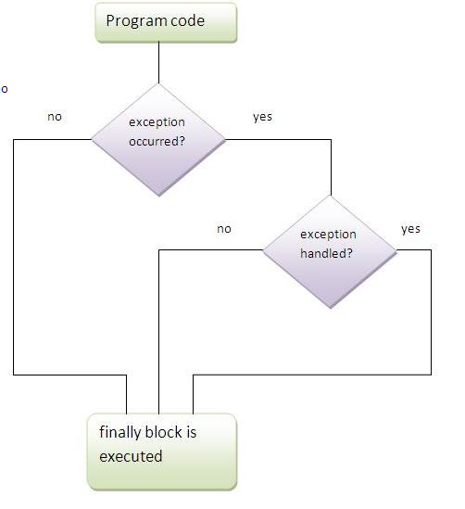

Note: If you don't handle exception, before terminating the program, JVM executes finally block(if any).

Why use java finally
- Finally block in java can be used to put "cleanup" code such as closing a file, closing connection etc.

Usage of Java finally
Let's see the different cases where java finally block can be used.

Case 1
Let's see the java finally example where exception doesn't occur.
- class TestFinallyBlock{
- public static void main(String args[]){
- try{
- int data=25/5;
- System.out.println(data);
- }
- catch(NullPointerException e){System.out.println(e);}
- finally{System.out.println("finally block is always executed");}
- System.out.println("rest of the code...");
- }
- }
Test it Now
Output:5
finally block is always executed
rest of the code...

Case 2
Let's see the java finally example where exception occurs and not handled.
- class TestFinallyBlock1{
- public static void main(String args[]){
- try{
- int data=25/0;
- System.out.println(data);
- }
- catch(NullPointerException e){System.out.println(e);}
- finally{System.out.println("finally block is always executed");}
- System.out.println("rest of the code...");
- }
- }
Test it Now
Output:finally block is always executed
Exception in thread main java.lang.ArithmeticException:/ by zero

Case 3
Let's see the java finally example where exception occurs and handled.
- public class TestFinallyBlock2{
- public static void main(String args[]){
- try{
- int data=25/0;
- System.out.println(data);
- }
- catch(ArithmeticException e){System.out.println(e);}
- finally{System.out.println("finally block is always executed");}
- System.out.println("rest of the code...");
- }
- }
Test it Now
Output:Exception in thread main java.lang.ArithmeticException:/ by zero
finally block is always executed
rest of the code...

Rule: For each try block there can be zero or more catch blocks, but only one finally block.

Note: The finally block will not be executed if program exits(either by calling System.exit() or by causing a fatal error that causes the process to abort).

Java throw keyword
The Java throw keyword is used to explicitly throw an exception.
We can throw either checked or uncheked exception in java by throw keyword. The throw keyword is mainly used to throw custom exception. We will see custom exceptions later.
The syntax of java throw keyword is given below.
- throw exception;
Let's see the example of throw IOException.
- throw new IOException("sorry device error);

java throw keyword example
In this example, we have created the validate method that takes integer value as a parameter. If the age is less than 18, we are throwing the ArithmeticException otherwise print a message welcome to vote.
- public class TestThrow1{
- static void validate(int age){
- if(age<18)
- throw new ArithmeticException("not valid");
- else
- System.out.println("welcome to vote");
- }
- public static void main(String args[]){
- validate(13);
- System.out.println("rest of the code...");
- }
- }
Test it Now
Output:
Exception in thread main java.lang.ArithmeticException:not valid

Java Exception propagation
An exception is first thrown from the top of the stack and if it is not caught, it drops down the call stack to the previous method,If not caught there, the exception again drops down to the previous method, and so on until they are caught or until they reach the very bottom of the call stack.This is called exception propagation.

Rule: By default Unchecked Exceptions are forwarded in calling chain (propagated)

Program of Exception Propagation
- class TestExceptionPropagation1{
- void m(){
- int data=50/0;
- }
- void n(){
- m();
- }
- void p(){
- try{
- n();
- }catch(Exception e){System.out.println("exception handled");}
- }
- public static void main(String args[]){
- TestExceptionPropagation1 obj=new TestExceptionPropagation1();
- obj.p();
- System.out.println("normal flow...");
- }
- }
Test it Now
Output:exception handled
normal flow...
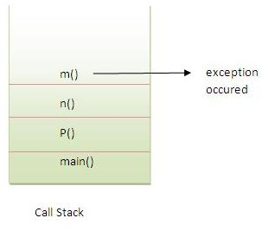
In the above example exception occurs in m() method where it is not handled,so it is propagated to previous n() method where it is not handled, again it is propagated to p() method where exception is handled.
Exception can be handled in any method in call stack either in main() method,p() method,n() method or m() method.

Rule: By default, Checked Exceptions are not forwarded in calling chain (propagated).
Program which describes that checked exceptions are not propagated
- class TestExceptionPropagation2{
- void m(){
- throw new java.io.IOException("device error");//checked exception
- }
- void n(){
- m();
- }
- void p(){
- try{
- n();
- }catch(Exception e){System.out.println("exception handeled");}
- }
- public static void main(String args[]){
- TestExceptionPropagation2 obj=new TestExceptionPropagation2();
- obj.p();
- System.out.println("normal flow");
- }
- }
Test it Now
Output:Compile Time Error

Java throws keyword
The Java throws keyword is used to declare an exception. It gives an information to the programmer that there may occur an exception so it is better for the programmer to provide the exception handling code so that normal flow can be maintained.
Exception Handling is mainly used to handle the checked exceptions. If there occurs any unchecked exception such as NullPointerException, it is programmers fault that he is not performing check up before the code being used.

Syntax of java throws
- return_type method_name() throws exception_class_name{
- //method code
- }

Which exception should be declared
Ans) checked exception only, because:
- unchecked Exception: under your control so correct your code.
- error: beyond your control e.g. you are unable to do anything if there occurs VirtualMachineError or StackOverflowError.

Advantage of Java throws keyword
Now Checked Exception can be propagated (forwarded in call stack).
It provides information to the caller of the method about the exception.

Java throws example
Let's see the example of java throws clause which describes that checked exceptions can be propagated by throws keyword.
- import java.io.IOException;
- class Testthrows1{
- void m()throws IOException{
- throw new IOException("device error");//checked exception
- }
- void n()throws IOException{
- m();
- }
- void p(){
- try{
- n();
- }catch(Exception e){System.out.println("exception handled");}
- }
- public static void main(String args[]){
- Testthrows1 obj=new Testthrows1();
- obj.p();
- System.out.println("normal flow...");
- }
- }
Test it Now
Output:
exception handled
normal flow...

Rule: If you are calling a method that declares an exception, you must either caught or declare the exception.
There are two cases:
- Case1:You caught the exception i.e. handle the exception using try/catch.
- Case2:You declare the exception i.e. specifying throws with the method.

Case1: You handle the exception
- In case you handle the exception, the code will be executed fine whether exception occurs during the program or not.
- import java.io.*;
- class M{
- void method()throws IOException{
- throw new IOException("device error");
- }
- }
- public class Testthrows2{
- public static void main(String args[]){
- try{
- M m=new M();
- m.method();
- }catch(Exception e){System.out.println("exception handled");}

- System.out.println("normal flow...");
- }
- }
Test it Now
Output:exception handled
normal flow...

Case2: You declare the exception
- A)In case you declare the exception, if exception does not occur, the code will be executed fine.
- B)In case you declare the exception if exception occures, an exception will be thrown at runtime because throws does not handle the exception.
A)Program if exception does not occur
- import java.io.*;
- class M{
- void method()throws IOException{
- System.out.println("device operation performed");
- }
- }
- class Testthrows3{
- public static void main(String args[])throws IOException{//declare exception
- M m=new M();
- m.method();

- System.out.println("normal flow...");
- }
- }
Test it Now
Output:device operation performed
normal flow...
B)Program if exception occurs
- import java.io.*;
- class M{
- void method()throws IOException{
- throw new IOException("device error");
- }
- }
- class Testthrows4{
- public static void main(String args[])throws IOException{//declare exception
- M m=new M();
- m.method();

- System.out.println("normal flow...");
- }
- }
Test it Now
Output:Runtime Exception

Question) Can we rethrow an exception?
Yes, by throwing same exception in catch block.
No. | throw | throws
1) | Java throw keyword is used to explicitly throw an exception. | Java throws keyword is used to declare an exception.
2) | Checked exception cannot be propagated using throw only. | Checked exception can be propagated with throws.
3) | Throw is followed by an instance. | Throws is followed by class.
4) | Throw is used within the method. | Throws is used with the method signature.
5) | You cannot throw multiple exceptions. | You can declare multiple exceptions e.g.  public void method()throws IOException,SQLException.

No. | final | finally | finalize
1) | Final is used to apply restrictions on class, method and variable. Final class can't be inherited, final method can't be overridden and final variable value can't be changed. | Finally is used to place important code, it will be executed whether exception is handled or not. | Finalize is used to perform clean up processing just before object is garbage collected.
2) | Final is a keyword. | Finally is a block. | Finalize is a method.

Java final example
- class FinalExample{
- public static void main(String[] args){
- final int x=100;
- x=200;//Compile Time Error
- }}

Java finally example
- class FinallyExample{
- public static void main(String[] args){
- try{
- int x=300;
- }catch(Exception e){System.out.println(e);}
- finally{System.out.println("finally block is executed");}
- }}

Java finalize example
- class FinalizeExample{
- public void finalize(){System.out.println("finalize called");}
- public static void main(String[] args){
- FinalizeExample f1=new FinalizeExample();
- FinalizeExample f2=new FinalizeExample();
- f1=null;
- f2=null;
- System.gc();
- }}

Java Custom Exception or User-defined Exception
If you are creating your own Exception that is known as custom exception or user-defined exception. Java custom exceptions are used to customize the exception according to user need.
By the help of custom exception, you can have your own exception and message.
Let's see a simple example of java custom exception.
- class InvalidAgeException extends Exception{
- InvalidAgeException(String s){
- super(s);
- }
- }
- class TestCustomException1{

- static void validate(int age)throws InvalidAgeException{
- if(age<18)
- throw new InvalidAgeException("not valid");
- else
- System.out.println("welcome to vote");
- }

- public static void main(String args[]){
- try{
- validate(13);
- }catch(Exception m){System.out.println("Exception occured: "+m);}

- System.out.println("rest of the code...");
- }
- }
Test it Now
Output:Exception occured: InvalidAgeException:not valid
rest of the code...

